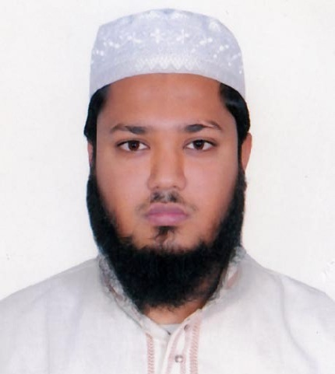
Md. Ikram Alamin Khan
 iradkhan221@gmail.com

www.linkedin.com/in/ikramkhan221

Khilket, Dhaka.
+88-01680885717

Career Objective

In the field of corporate, I need an opportunity to apply my dynamic concept, hard work to develop a successful business model.
I have to achieve my goal with success. I believe of my hard work, tenacity, adamateness, discipline and honesty will help me to achieve my target.

Work Experience


Grambangla
Position: Founder CEO
Bangladesh Branch
Date: April, 2018 -At Present
Web: www.gram-bangla.com.bd

Job Responsibilities:
- Creating, communicating, and implementing the organization's vision, mission for organization.
- Execute plan according to business strategy.
- Leading the development and implementation of the overall organization's strategy.
- Purchase and Import several products from china and make product cost report.
- Achieve sales target and try to make new potential client.
- Communicate and maintain Relationship with corporate client (B2B).
- Make new business development idea and planning with proper report.
- Increase the sales with new marketing policy through online.
- Try to make new routes for business development with technology.
- Make plan for achieve market share from competitors.
- Analysis information of other competitors.
- Extra activity- Vat, tax, L/C, Inco term, Facebook promotion, ERP Software Maintain.


Anyang Jin chao yang co, Ltd;
Henan, China
Position: Marketing Executive
Bangladesh Branch
Date: Jan, 2018- March, 2018


Livingtex
Department: Communication
Position: IT Executive.
Date: 2017, Sep-2017, Dec (4 Month)
Web: livingtexglobal.com

Narina Technology Ltd.
Department: Software
Position: Intern (Web Developer).
Date: 2017, March- 2017, June (3 months).

Technical Skills

- Object-oriented programming
- Language: C, Java (Basic), Php, MySQL,
JavaScript, HTML, CSS, Bootstraps.
- Framework: Laravel (beginning level).
- Wordpress.
- Tools: Gitlab, Github, Slack, Trello, MS Office
.

Key Skills

- Interested to learn new things.
- Project handling capability.
- Quick learner.
- Team oriented.
- Stress Tolerance.
- Creative thinking & innovation.
- Stress Management.
- Time Management.

Professional Training

Name of the course : Web Design and Development using PHP
Organization : Rosetta Technology under LICT project, ICT Ministry of Bangladesh.
Period : February 2017 to April 2017

Name of the Course : Web Design and Development using PHP
Organization : BASIS Institute of Technology & Management under SEIP Project,
Finance Ministry of Bangladesh.
Period : November 2015 to February 2016

Name of the course : Hardware Networking (Comptia A+)
Organization : New Horizons CLC of Bangladesh.
Period : January 2012 to March 2012

Educational Information

Degree | Institution | Major | Result | Year
B.Sc. | Daffodil International University (DIU) | CSE | 3.63 (out of 4) | 2017
Diploma | Kishoreganj Polytechnic Institute | Computer | 3.38 (out of 4) | 2013
S.S.C | Jafrabad High School | Science | 4.81 (out of 5)) | 2008

Language Skills

Language | Understanding | Speaking | Reading | Writing
English | Good | Good | Excellent | Good
Bengali | Excellent | Excellent | Excellent | Excellent

Personal Information

Father’s Name | Md. Mahfujul Amin Khan
Mother’s Name | Azizunessa
Marital Status | Unmarried
Date of Birth | 15th , October, 1992
Nationality | Bangladeshi (By birth)
Religion | Islam (Sunni)
Physique & Complexion | Height - 5’ 6”, Fair Complexioned

Permanent Address Present Address

C/O Mahfuj Khan
Village : Jafrabad (Mastarbari).
P.O : Jangalbari.

P.S. : Karimganj.
District : Kishoreganj, Bangladesh.

1st floor, Kha-22/2, Khilket,
Dhaka.

References

- Prof. Dr. Syed Akhter Hossain
Head, Department of CSE
Daffodil International University
aktarhossain@daffodilvarsity.edu.bd
+8801817 382645

- Yusuf Zaman Khan
Area manager & Head of Branch (First assistant Vice president)
Brac bank.
01713047202


I do hereby declaring that all of the information and description about me mentioned above are factual. This information can be verified by mentioned references.

Signature (Md. Ikram Alamin Khan)

